Introduction to Processing

Worksheet 1

# Questions

## Introduction to Drawing on Processing

1. Design 3 cartoonish human faces using simple shapes and colours. Draw the human faces using only points, lines, rectangles, and ellipses.
2. Design 2 animal faces using simple shapes and colours. Draw the animal faces using only points, lines, rectangles, and ellipses.

## Mouse Control

1. Draw on processing a stick person whose body moves with mouse movements.
2. Replicate one of Piet Mondrian’s pieces programmatically.
3. Use the result of Question 4 to create an interactive art where the user can draw behind Mondrian’s art. The interaction has to include the drawing of ellipses or rectangles depending on which mouse button is clicked.
4. Write a program that makes the user explore the screen real-estate. The program has to display a clean background and different shapes are drawn when the user clicks on different quadrants of the screen. For example, if the user clicks on the top left quadrant, rectangles are drawn while when clicking on the bottom right quadrant, circles are drawn.
5. Replicate Theo van Doesburg’s piece titled “*Composition VII- The Three Graces*”

## Random Numbers

1. Write a program that draws black points of random stroke weight varying from 10 to 100 in different locations in the screen. The points with stroke weight between 40 and 50 should be red and those between 60 and 70 green.

## For-Loops

1. Write a set of programs to generate the following graphics:

|  |  |  |
| --- | --- | --- |
| HOMEWORK/TASK%204/SHAPES_AND_COLOURS_WITH_FOR_LOOPS_2/Screen%20Shot%202015-01-16%20at%2016.26.13.png | HOMEWORK/TASK%204/SHAPES_AND_COLOURS_WITH_FOR_LOOPS_1/Screen%20Shot%202015-01-16%20at%2016.25.49.png | HOMEWORK/TASK%204/SHAPES_AND_COLOURS_WITH_FOR_LOOPS_3/Screen%20Shot%202015-01-16%20at%2016.26.44.png |

1. Write a program to generate curved shapes such as the ones below using only for-loops and straight lines. You are not required to replicate this exact graphic.

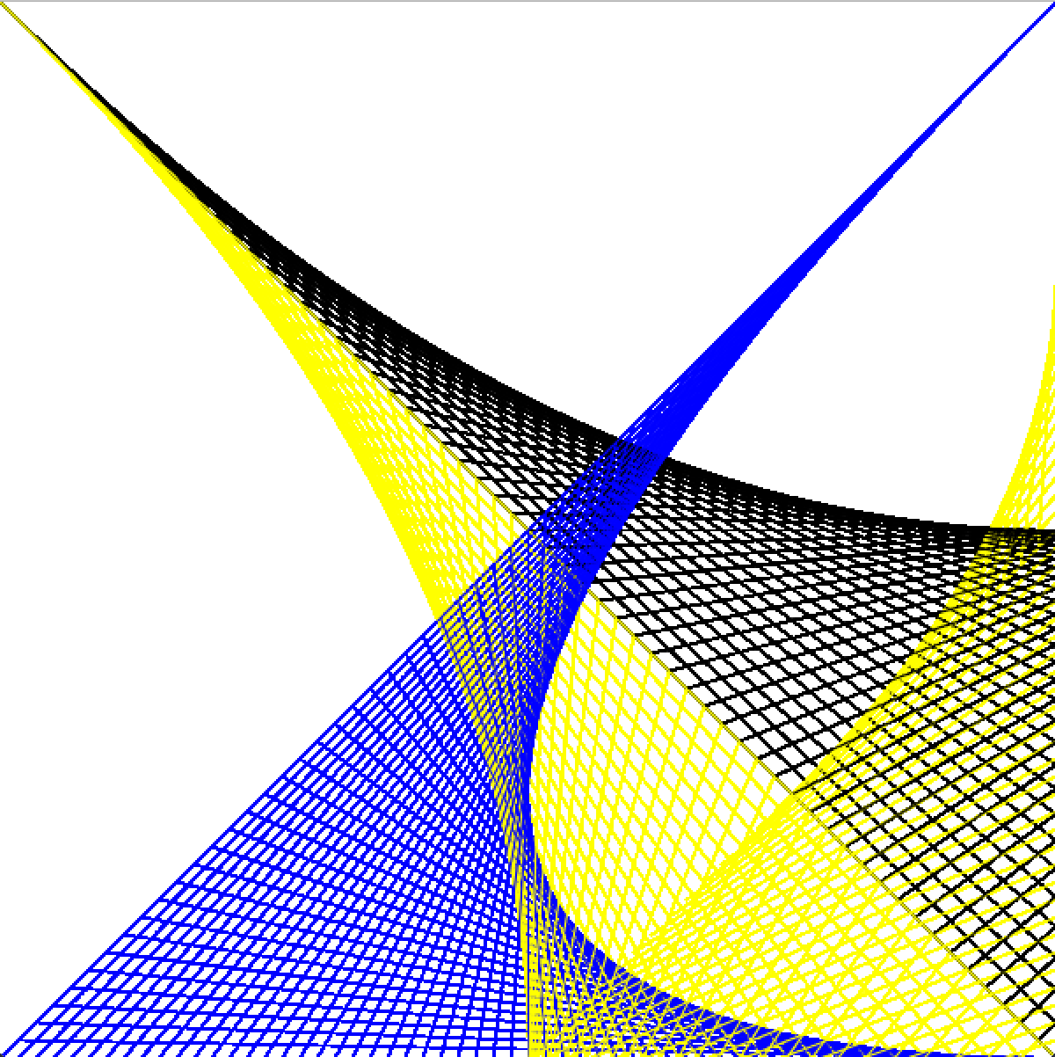

1. Write a program that draws 2 diagonal triangles as in the image below by randomly generating differently coloured points in the region. The program has to leave a box in the centre of the screen free of any random point. You only need to use for-loops, if statements and random generators.

